Gedling Borough Council
Community Infrastructure Levy (CIL)

Infrastructure Funding Statement 2022/23

Published December 2023

1 INTRODUCTION
Welcome to the Gedling Borough Council Infrastructure Funding Statement. This statement sets out the income and expenditure relating to the Community Infrastructure Levy (CIL) and Section 106 (s106) Agreements during the financial year 22/23.
Local Authorities are required to produce an annual Infrastructure Funding Statement as part of the Community Infrastructure Levy (Amendment) (England) (No. 2) Regulations 2019.
Income collected from the CIL and / or s106 (collectively known as ‘planning obligations’ or ‘developer contributions’) is used to help fund the provision of infrastructure which is necessary to support and enable development and growth within the Borough.
Sections 2 and 3 of this statement will provide details of the progress in relation to the collection and expenditure of income generated through the CIL and s106 respectively for the last financial year.
Section 4 sets out the planned future expenditure of income generated through these mechanisms over the next reporting period.
1.1 Community Infrastructure Levy & Section 106 Agreements
The Community Infrastructure Levy is a tariff-based charge on the development of new floorspace within the borough. Monies collected through the CIL can be used to fund a wide range of infrastructure (e.g. roads, medical practices and the provision of open space) that is required to meet the future growth needs of the borough.
The Gedling Borough Community Infrastructure Levy (CIL) Charging Schedule was approved by Full Council on 15th July 2015 and came into effect on 16th October 2015. Planning applications decided on or after 16th October 2015 may therefore be subject to CIL.

Section 106 agreements are private agreements, made between local authorities and developers, which can be attached to a planning permission to ensure that a certain development that may otherwise be unacceptable in planning terms, meets the local planning authorities policy requirements. Typical forms of Section 106 Obligations include:
- Site-specific financial contribution;
- Non-financial obligations; and
- Provision of on-site affordable housing.
1.2 Summary of Headlines within Statement
Table 1. Key Headlines from the Statement.
Summary of CIL Receipts
A total of £1,657,474 in CIL receipts were collected during the financial year 2022/23.

A total of £5,614,450 receipts were retained at the end of the financial year 2022/23. Of this, £5,338,039 is to be used towards the provision of Strategic Infrastructure within the Borough, whilst £276,411 remains for Infrastructure projects identified through the Neighbourhood portion of the CIL.

A total of £232,190 was passed to Local Parishes during 2022/23 in accordance with Regulations 59A.

A total of £82,874 was allocated to cover the administrative costs of implementing and monitoring the CIL during 2022/23.

Summary of Section 106 Contributions
During the 2022/23 financial year £642,731 was collected in capital contributions through Section 106 Obligations. £156,980 was collection in revenue contributions during the same period.

A total of £280,058 capital and £29,729 revenue contributions have been spent on infrastructure within Gedling Borough Council during the 2022/23 financial year.

At the end of the financial year 2022/23, £3,538,877 worth of capital contributions were retained by Gedling Borough Council.

Non-financial contributions such as the provision of Affordable Housing and Employment and Skills Plans / Local Labour Agreements continue to be secured by way of Section 106 Obligations within the Borough.

2 COMMUNITY INFRASTRUCTURE LEVY
The amount of CIL payable depends on where the development is located within the borough, the type of use the development comprises of, and the net additional increase in floorspace (£ per Sqm).
Gedling Borough Council’s Charging Schedule currently identifies two different types of Uses which are liable for the CIL. Retail development chargeable by a flat rate across the borough whilst new residential development is split into three different zones. The Charging Schedule and Map of the different zones are available to view from our website at https://www.gedling.gov.uk/cil/.
Alongside the Charging Schedule Gedling Borough Council also adopted a Regulation 123 List in accordance with the regulations in force at the time. Expenditure of the Strategic CIL receipt was approved for the following infrastructure projects:
- The Gedling Access Road (GAR);
- Secondary School Contributions for Gedling Colliery / Chase Farm and Top Wighay Farm strategic sites; and
- The Gedling Country Park Visitors Centre.
The Regulation 123 List has since been abolished as part of the CIL Amendment Regulations 2019 and replaced with the new ‘Infrastructure List’. No new projects have been added to the Infrastructure List.
Unlike Section 106 Agreements, the CIL payable is a fixed rate which is mandatory and non-negotiable. The charge becomes payable upon the commencement of development.
2.1 CIL Income
Table 2 below provides a cumulative total of all CIL receipts retained by Gedling Borough Council since its first adopted of the CIL in 2015. A breakdown of these receipts is provided in greater detail further into the report.
Table 2. Cumulative Total CIL Receipts Retained (to the nearest £)
Year | Income
2015/16 | £0
2016/17 | £36,171
2017/18 | £420,148
2018/19 | £1,038,139
2019/20 | £1,276,677
2020/21 | £1,671,993
2021/22 | £4,272,039
2022/23 | £5,614,450

Gedling Borough Council adopted the CIL on 16th October 2015. In accordance with the Community Infrastructure Levy (Amendment) (England) (No. 2) Regulations 2019, any planning application which was determined prior to this date is not chargeable. It is for this reason, along with a gap between the granting of permission and implemented, that no receipts were collected during the 2015/16 financial year.
2.2 Breakdown of CIL for 2022/23
During the reported year 2022/23, 15 Demand Notices were issued totalling £2,324,654 in CIL Receipts. To date a total of £1,859,099 of these receipts have been collected. The remaining sums will be collected in accordance with the relevant payment plans as approved in the Councils Charging Schedule. The collection of the remaining sums from these Demand Notices will be reported in future Infrastructure Funding Statements in accordance with relevant payment policies.
During the reported year 2022/23 there has been a total of £1,657,474 collected in CIL receipts from across 17 different developments. A summary of the allocation of receipts collected during the year is detailed in Table 3 below.
Table 3. Annual Breakdown of CIL Receipts 1st April 2022 - 31st March 2023 (to the nearest £)
Total Receipts Collected | £1,657,474
Neighbourhood Portion of CIL Receipts | £334,301
Strategic Element of CIL Receipts | £1,240,299
Administration Element of CIL Receipts | £82,874
Receipts Spent on Strategic Infrastructure | £0
Receipts Passed to Local Parishes | £232,190
Receipts Awarded to Non-Parish Neighbourhood Projects | £0
CIL Receipts Retained at End of Year | £1,342,410

Of the receipts which were collected during 2022/23, £1,240,299 is to be spent on strategic infrastructure projects that were identified on the Infrastructure List (previously Regulation 123 List), while £334,301 is to be spent in the locality it was collected as part of the neighbourhood portion of the CIL.
In accordance with Regulation 59A of the Community Infrastructure Levy (Amendment) (England) (No. 2) Regulations 2019, a total of £232,190 from the Neighbourhood Portion of CIL Receipts has been passed directly to the Local Parishes from where they were collected.
£82,874 (5%) of all receipts collected during the financial year, have been set aside to cover the administration costs as permitted by the Community Infrastructure Levy (Amendment) (England) (No. 2) Regulations 2019.
During the financial year 2022/23, it was considered that none of the nominated projects for the annual Non-Parish Neighbourhood Funding Awards were suitable for funding at such time. Subsequently £0 was allocated to Non-Parish Neighbourhood Projects. Details of the nominated projects and the officer recommendations can be found on the Non-Parish Neighbourhood Page of the Gedling Borough Council website and by viewing the minutes of the Cabinet Meeting on the 7th September 2023. The nominated projects have been retained on the Local Infrastructure Schedule and any Non-Parish Neighbourhood receipts not allocated to projects will be carried over for consideration in 2023/24 in accordance with Regulation 59F of the Community Infrastructure Levy (Amendment) (England) (No. 2) Regulations 2019.
A total of £1,342,410 in CIL receipts were retained at the end of the financial year 2021/22 which, when added to the previous years retained receipts, results in a total of £5,614,450 held by Gedling Borough Council.
2.2.1 Strategic CIL
Since its adoption of CIL, to the end of the financial year 2022/23, Gedling Borough Council has collected £5,338,039 towards the provision of its strategic projects.
Table 4. Annual Strategic CIL Collected (to the nearest £)
Year | Income
2015/16 | £0
2016/17 | £33,695
2017/18 | £333,580
2018/19 | £530,147
2019/20 | £332,116
2020/21 | £437,359
2021/22 | £2,430,843
2022/23 | £1,240,299
Total | £5,338,039

Following its introduction in 2015, the strategic portion of the CIL collected has been retained for the construction of Gedling Access Road (GAR) which remains the Council’s first priority in terms of key infrastructure within the Borough. The GAR, subsequently named Colliery Way, is a new 3.8km single carriageway road which provides a link between the B684 Mapperley Plains and the A612 Trent Valley Road / Nottingham Road. This new piece of infrastructure is vital to supporting the residential growth in this area. Construction of the GAR began in January 2020 and was completed in Spring 2022.
When adopting the CIL Gedling Borough Council agreed to make a contribution of up to £4.48 million from the Strategic CIL receipts to part fund the GAR. In Autumn 2023 the Borough Council transferred approx. £4.44m to Nottinghamshire County Council to fund the construction of the GAR. This payment will be fully reported in next year’s Infrastructure Funding Statement.
Figure 1. Map of Gedling Access Road / Colliery Way
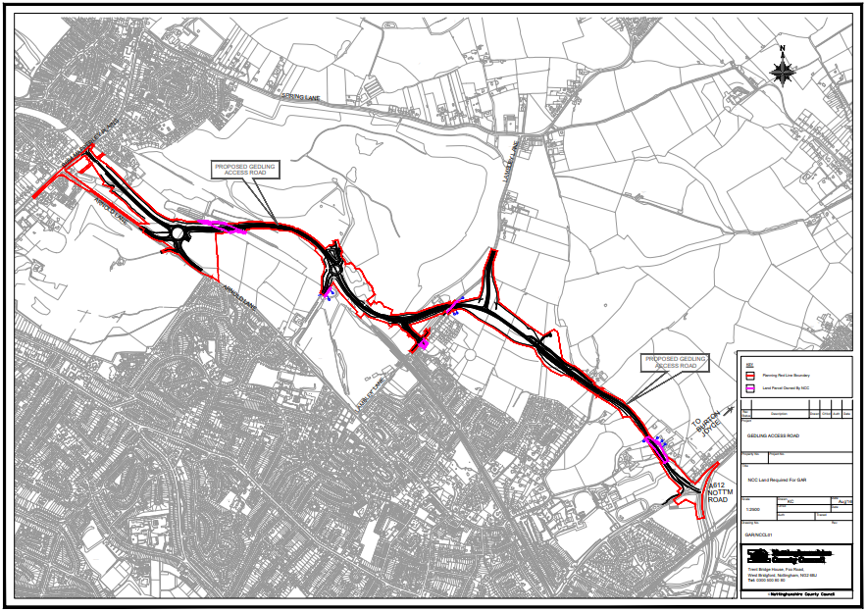
2.2.2 Neighbourhood CIL
Under the Community Infrastructure Levy (Amendment) (England) (No. 2) Regulations 2019 a ‘meaningful proportion of CIL receipts are to be passed to local town or parish councils for the area where development takes place. This is known as the ‘neighbourhood portion’. The neighbourhood portion to be passed to the local council is set at 15% of the relevant CIL receipts (up to a cap of £100 per existing council tax dwelling) or 25% with no maximum cap specified where there is a Neighbourhood Development Plan in place. At this time there are four Neighbourhood Plans ‘made’ within Gedling Borough:
- Burton Joyce Neighbourhood Plan,
- Calverton Neighbourhood Plan,
- Linby Neighbourhood Plan, and
- Papplewick Neighbourhood Plan.
Table 5 below shows the portion of the Neighbourhood CIL Receipts which have been collected on behalf of local Parish Councils.
Table 5. Neighbourhood CIL Awarded to Local Parishes (to the nearest £)
Year | Income
2015/16 | £0
2016/17 | £3,842
2017/18 | £12,374
2018/19 | £8,059
2019/20 | £23,808
2020/21 | £45,304
2021/22 | £373,379
2022/23 | £232,190
Total | £698,956

Where there is no Parish Council, Regulation 59A of the Community Infrastructure Levy (Amendment) (England) (No. 2) Regulations 2019 places a duty on charging authorities to allocate at least 15% (up to a cap of £100 per existing council tax dwelling) or 25% (uncapped) where there is a ‘made’ Neighbourhood Plan, of CIL receipts to spend on priorities that should be agreed with the local community in areas where development is taking place. Gedling Borough Council undertake annual consultations with local residents and groups to identify and assess projects which may be suitable for Non-Parish neighbourhood funding. Where no suitable projects are identified the Neighbourhood portion is carried over to the next financial year. Further information regarding the Neighbourhood portion of the CIL can be found on the Gedling Borough Council website at https://www.gedling.gov.uk/cil/.

Gedling Borough has 11 Parishes where the Neighbourhood portion of CIL Receipts will be passed to the Parish Councils if developments take place in those areas. The Parishes cover the following areas:

- Bestwood Village;
- Burton Joyce;
- Calverton;
- Colwick;
- Lambley;
- Linby;
- Newstead;
- Papplewick;
- Ravenshead;
- St Albans, and
- Woodborough.

In accordance with the Community Infrastructure Levy (Amendment) (England) (No. 2) Regulations 2019, Parish Councils must publish their own annual reports which detail funding and expenditure for each year where they have received monies passed down through the Neighbourhood Portion through CIL.
It should be noted that the extent of the Parishes does not cover the majority of the urban area of Gedling Borough (with the exception of Colwick). This creates a gap in the coverage for the Neighbourhood portion in the Borough. When development takes place in this area Gedling Borough Council will determine, in consultation with its residents, how to expend this element of the CIL in accordance with Regulation 59F of with the Community Infrastructure Levy (Amendment) (England) (No. 2) Regulations 2019.
Below is a table showing the amount of CIL which has been collected and allocated towards the Non-Parish Neighbourhood element during the last financial year.
Table 6. Non-Parish Neighbourhood CIL Collected (to the nearest £)
Year | Income
2015/16 | £0
2016/17 | £2,476
2017/18 | £50,397
2018/19 | £91,344
2019/20 | £46,423
2020/21 | £50,957
2021/22 | £249,963
2022/23 | £102,111
Total | £593,671

To date Gedling Borough Council have awarded a total of £317,260 through the Non-Parish Neighborhood portion, to seven different infrastructure projects. Table 7 below provides a summary of these projects. The projects can be found in greater detail in the relevant annual Infrastructure Funding Statements which are available on the Gedling Borough Council website.
Table 7. Summary of Non-Parish Neighbourhood CIL Awards
Project | Award | Year of Submission
Cinderpath Lighting | £3,500 | 17/18
Car Park Extension at Gedling Country Park | £100,000 | 18/19
Changing Room Facilities at Lambley Lane | £40,000 | 18/19
Green Lung Corridor | £50,000 | 19/20
Arnold Marketplace Development | £43,000 | 19/20
Footpath Extension at Willow Park | £25,000 | 20/21
Internal works and alterations at Netherfield Forum Children, Young People and Families Hub | £55,760 | 20/21
At the end of the financial year 2022/23 a total of £276,411 in CIL Receipts was retained by Gedling Borough Council for allocation towards the funding of future nominated projects. During 2022/23 a total of two projects were nominated and considered for Non-Parish Neighbourhood funding but were ultimately unsuccessful. These projects were retained on the Local Infrastructure Schedule for re-consideration as part of the 2023/24 nominations when they may be more suitable for Non-Parish Neighbourhood funding awards. Further information on these projects can be found by viewing the minutes of the relevant Cabinet Meeting on the 7th September 2023 which are publicly available on the Gedling Borough Council website.

2.2.3 CIL Administration Portion
The remaining 5% of monies collected through CIL Receipts is made available for Charging Authorities to cover the administrative costs associated with implementing and enforcing the CIL.
To date a total of £348,983 has been collected towards covering the costs of operating the CIL within Gedling Borough Council. Table 8 below shows a breakdown of the annual receipts collected towards this portion of the CIL.

Table 8. Administration CIL Collected (to the nearest £)
Year | Income
2015/16 | £0
2016/17 | £2,106
2017/18 | £20,861
2018/19 | £33,134
2019/20 | £21,176
2020/21 | £28,085
2021/22 | £160,747
2022/23 | £82,874
Total | £348,983

3 SECTION 106 OBLIGATIONS
Gedling Borough Councils approach to planning obligations is set out within the Aligned Core Strategy 2014 (Part 1 Local Plan), the Local Planning Document 2018 (Part 2 Local Plan) and Gedling Borough Councils Planning Obligations Protocol 2014. Priorities which should be considered when negotiating planning applications include factors such as Affordable Housing, Open Space, Education and Primary Healthcare.
More detailed guidance regarding how obligations are calculated can be found in Gedling Borough Councils Supplementary Planning Documents and Guidance on the Gedling Borough Councils website at https://www.gedling.gov.uk/resident/planningandbuildingcontrol/planningpolicy/adoptedlocalplanandpolicydocuments/.
3.1 New Section 106 Agreements Signed
During the financial year 2022/23 there have been a total of 8 new planning permissions granted for developments which were subject to Section 106 Agreements. Of these 3 were new Section 106 Agreements and 5 were Variations to pre-existing Agreements. Table 9 below provides a list of these developments.

Table 9. List of New Section 106 Agreements 2022/23 (to the nearest £)
App Ref | Location | Breakdown of Obligations
2017/0999 (Deed of Variation) | Teal Close, Netherfield | Cycle / Footway Works Contribution - £150,000  Lowdham Roundabout Improvements Contribution - £64,932.75
2021/1363 (Deed of Variation) | Former Car Park, North Green, Calverton, Nottingham | No new obligations. Purpose of DoV is to tie new permissions to original agreement.
2021/1471 (Deed of Variation) | Land at Rolleston Drive, Arnold, Nottingham | No new obligations. Purpose of DoV is to tie new permissions to original agreement.
2020/1254 | 73 Burton Road, Carlton, Nottingham | Local Labour Agreement.  Monitoring Fee £630.  Viability Re-Appraisal. If found viable:  - Affordable Housing Contribution  - Bus Stop Contribution
2020/1312 | 53 Woodthorpe Drive, Woodthorpe, Nottingham | Local Labour Agreement.  Primary Healthcare Contribution - £8,670.  Bus Stop Contribution - £6,000.
2022/0432 (Deed of Variation) | Land at Teal Close, Burton Joyce | Affordable Housing – First Homes.
2022/0240 | Netherfield Methodist Church, Victoria Road, Netherfield , Nottinghamshire | Local Employment and Skills Plan.  Bus Stop Contribution - £8,825.
2021/0668 (Deed of Variation) | Land Northwest of Park Road, Calverton, Nottingham | Affordable Housing Provisions.

A copy of each Section 106 Agreement and other public documents relevant to each Planning Application can be viewed electronically on the planning portal at https://pawam.gedling.gov.uk/online-applications/.
3.2 Section 106 Capital Contributions Overview
A total of £799,711 was received in Section 106 Contributions during the financial year 2022/23.
Table 10 provides a breakdown of the total contributions received from S106 Contributions and the amount of Expenditure over the last financial year.
Table 10. Overview of S106 Contributions 2022/23 (to the nearest £)
Contributions Received |  | Expenditure
Capital | Revenue | Capital | Revenue
£642,731 | £156,980 | £280,058 | £29,729

The figures above represent a similar level of income in relation to Capital Contributions collected during the last fiscal year whilst Revenue Contributions were approximately doubled. In addition to this, Capital Expenditure rose from £13,825 to £280,058, demonstrating the Councils commitment to ensuring delivery of infrastructure to mitigate the impacts of relevant development.
Figure 3. Annual Comparison of S106 Income and Expenditure
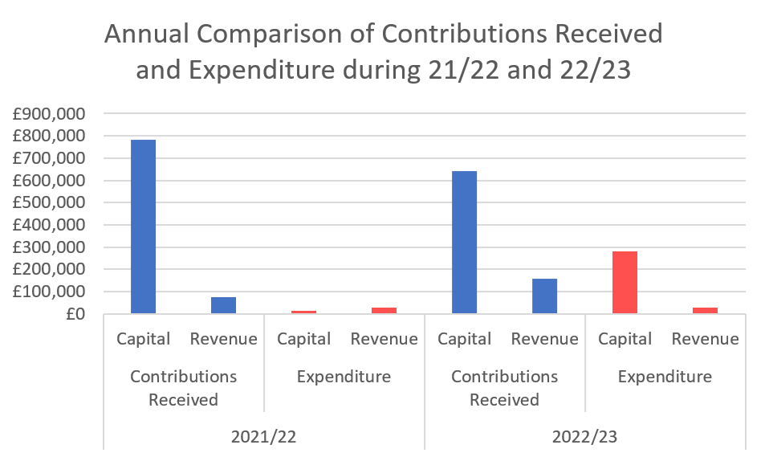
3.3 Capital Contributions retained at end of Financial Year 2022/23
Contributions collected through a Section 106 agreement usually have a clause stating the timeframe in which the contribution is to be expended. Currently there are no S106 contributions which have exceeded the timeframe and plans are in place to ensure that the contributions are expended prior to the repayment dates set.
In the majority of S106 agreements the payback period is usually 10 years however these clauses can range between 5 – 10 years.
Table 11 below details the Capital Contributions which have been retained at the end of the financial year 2022/23. These monies have yet to be allocated to a specific scheme or project.

Table 11. Capital Contributions held as of 31st March 2023 (to the nearest £)
Site | Application Reference | S106 Received | Contributions Held | Provision | Deadline for expenditure
Spring Lane | 2007/0748 | 2014 | £24,924 | Affordable Housing | 2024
 |  |  | £11,863 | Open Space
Land Between Main St and Hollinwood | 2012/0941 | 2019 | £99,536 | Open Space | 2029
Land at Wighay Road | 2014/0950 | 2016 | £94,822 | Open Space | 2026
 |  |  | £560,567 | Affordable Housing
 |  |  | £21,741 | Healthcare
Land at Stockings Farm | 2010/0437 | 2016 | £435,232 | Healthcare | 2026
Bradstone Drive, off Spring Lane | 2014/0740 | 2017 | £23,903 | Healthcare | 2027
Land North of Papplewick Lane, Linby | 2013/1406 | 2017 | £37,346 | Healthcare | 2027
 |  |  | £215,568 | Affordable Housing | 2028
 |  | 2020 | £454,104 | Affordable Housing | 2030
 |  |  | £81,739 | Healthcare | 2030
Land Off Cavendish Road | 2014/0559 | 2017 | £35,243 | Open Space | 2027
Land at Teal Close, Netherfield | 2013/0546 | 2019 | £111,237 | Healthcare | 2029
Land West of Westhouse Farm | 2014/0238 | 2019 | £27,818 | Healthcare | 2029
 |  | 2021 | £164,831 | Open Space | 2031
 |  | 2021 | £54,939 | Open Space | 2031
Land west of Beeston Close, Bestwood | 2017/0194 | 2020 | £36,251 | Open Space | 2030
Bradstone Drive, off Spring Lane | 2014/0740 | 2020 | £22,692 | Healthcare | 2030
Land to the West of Mapperley Plain | 2019/0213 | 2020 | £44,434 | Healthcare | 2030
Rolleston Drive | 2020/1054 | 2021 | £250,688 | Education | 2031
 |  |  | £25,000 | Bus Stop | 2031
 |  |  | £35,493 | Healthcare | 2031
96 Plans Road Mapperley | 2021/0737 | 2021 | £17,636 | Open Space | 2031
84-86 Chapel Lane | 2019/0770 | 2021 | £30,359 | Open Space | 2031
Dark Lane | 2017/1263 | 2021 | £39,862 | Open Space | 2031
 |  |  | £18,713 | Healthcare | 2031
Dark Lane | 2017/1263 | 2022 | £53,037 | Affordable Housing | 2032
Glebe Farm | 2014/0475 | 2021 | £15,028 | Healthcare | 2031
Metalifacture | 2016/0854 | 2022 | £142,819 | Affordable Housing | 2032
Cornwater Fields | 2013/0836 | 2022 | £103,224 | Open Space | 2032
84-86 Chapel Lne | 2019/0770 | 2022 | £13,500 | Open Space | 2032
Rolleston Drive | 2020/1054 | 2022 | £78,197 | Open Space | 2032
Wood Lane | 2018/0577 | 2022 | £19,681 | Open Space | 2032
Metalifacture | 2016/0854 | 2022 | £42,692 | HealthCare | 2032
Burton Road | 2019/1186 | 2022 | £79,549 | HealthCare | 2032
Flatts Lane | 2018/1143 | 2022 | £14,609 | HealthCare | 2032
 |  |  | £3,538,877

Figure 4 below provides a breakdown of all the contributions currently held by Gedling Borough Council per service provision.
Figure 4. Pie Chart showing S106 Contributions held per type of provision
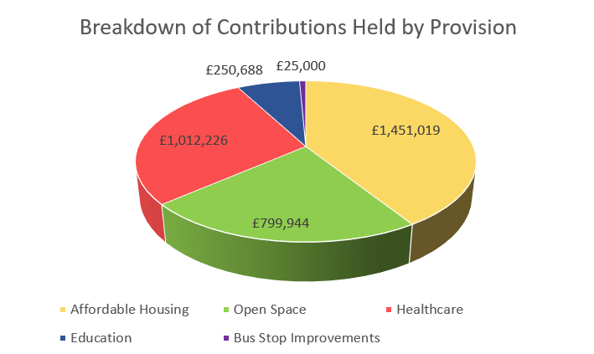
It should be noted that Gedling Borough Council have collected financial contributions towards the provision of both Education and Bus Stop Improvements. Whilst it is typically the responsibility of Nottinghamshire County Council to collect contributions regarding Education and Highways Improvements, in each of the relevant cases above, the County Council were the applicants for planning permission and as such were unable to collect the monies from themselves. Gedling Borough Council will release the monies in accordance with the terms and obligations of the relevant Section 106 Agreements.
3.4 Section 106 Capital and Revenue Expenditure
In 2022/23 Section 106 Contributions totalling £280,058 were spent on infrastructure projects across the borough. Table 12 indicates which developments the contributions were drawn down from and what projects they were allocated to.
Table 12. Capital Contributions expended during 2022/23 (to the nearest £)
Site | Application Reference | S106 Contribution Received | Amount Spent | Provision/Project Funded
Mill Field Close, Burton Joyce | 2015/0424 | £69,946 | £69,946 | Covered outdoor Community Space / Garden at The Old School Building, Main Street, Burton Joyce
Land North West Park Road, Calverton | 2018/0607 | £36,336 | £36,336 | Enhancement of play facilities at William Lee Memorial Park, Calverton
Land Adj Dark Lane, Calverton | 2017/1263 | £39,862 | £39,862 | Enhancement of play facilities at James Seely Park, Calverton
Land west of Beeston Close, Bestwood | 2017/0194 | £36,286 | £575 | Bestwood Country Park - Topographical Surveys
Land North West Park Road, Calverton | 2018/0607 | £147,948 | £133,339 | Expansion and renovation of The Calverton Practice, 2a Wilfreds Square, Calverton
Land on Flatts Lane, Calverton | 2018/1143
Land Adj Dark Lane, Calverton | 2017/1263
Total |  |  | £280,058

As well as the collection and expenditure of capital contributions, it is not uncommon for Section 106 Agreements to require the payment of revenue contributions towards the ongoing maintenance of infrastructure which is provided. These payments are typically agreed for a period of 10 years. The majority of revenue contributions which are collected by Gedling Borough Council relate primarily to ongoing maintenance works on Open Spaces sites that the Council have adopted. Table 13 below sets out revenue contributions which have been collected by the Local Authority toward maintenance of projects.
Table 13. Revenue Contributions (to the nearest £)
Site | Date Received | Balance as of 1st April 2022 | Annual Payment 2022/23 | Remaining Balance as of 31st March 2023
Spring Lane | 2006 | £1,707 | £569 | £1,138
Park Road, Bestwood | 2006 | £17,880 | £0 | £17,880
Downham Close, Arnold | 2008 | £2,476 | £825 | £1,651
Arnold View Primary School | 2009 | £9,898 | £2,474 | £7,424
Burton Road, Gedling | 2009 | £2,292 | £763 | £1,529
188-194 Mapperley Plains | 2016 | £7,614 | £1,904 | £5,710
333-339 Mapperley Plains | 2016 | £9,635 | £2,409 | £7,226
Spring Lane | 2017 | £55,288 | £11,057 | £44,231
Land at Teal Close, Netherfield | 2018 | £2,550 | £0.00 | £2,550
Howbeck Road | 2020 | £24,764 | £3,096 | £21,668
Bailey Drive | 2022 | £66,320 | £6,632 | £59,688
Wood Lane | 2022 | £8,223 | £0.00 | £8,223
Total |  | £208,647 | £29,729 | £178,918

3.5 Section 106 Monitoring Fees
The Community Infrastructure Levy (Amendment) (England) (No. 2) Regulations 2019 introduced a provision for Local Authorities to insert Monitoring Clauses into future Section 106 Agreements. These clauses allow fees to be levied to support the costs of monitoring and reporting on the delivery of Section 106 planning obligations.
Whilst the amendments to the Regulations allows for monitoring fees to be levied, any such fee must be both fair and reasonable based on the Local Authorities estimates of the actual costs of monitoring the agreement. The Borough Council has an adopted policy which can be viewed on the council’s website at the following link - https://democracy.gedling.gov.uk/documents/s16689/Appendix%201%20Monitoring%20Fee%20Ststement.pdf.
During the financial year 2022/23 Gedling Borough Council completed 1 new Section 106 Agreement which included the provision of a Monitoring Fees in accordance with the above policy. A list of these developments and the relevant monitoring fees, including monitoring fees which have been sought in relation to pre-existing agreements, are detailed below. Upon receipt of the monitoring fee the relevant records will be removed from the table.
Table 14. Section 106 Agreements with Monitoring Fees (to the nearest £)
Site | Date S106 Signed | Value of Monitoring Fee | Status
Land On Flatts Lane, Calverton, Nottinghamshire | 03.03.2020 | £2,835 | Payment Due
Land at Orchard Close, Burton Joyce, Nottinghamshire | 26.03.2020 | £2,520 | Payment Due
Land at Brookfields Garden Centre, Mapperley Plains, Nottingham, NG3 5RW | 26.03.2020 | £2,205 | Not Commenced
Land at Chase Farm, Mapperley Plains, Mapperley, Nottingham | 09.07.2020 | £1,890 | Not Commenced
Land South of Main Street, Calverton, Nottinghamshire | 07.04.2021 | £2,205 | Not Commenced
Land East of 16 Kighill Lane, Ravenshead, Nottinghamshire | 22.04.2021 | £315 | Payment Due
Car Park, North Green, Calverton, Nottinghamshire | 11.06.2021 | £630 | Not Commenced
Top Wighay Farm, Wighay Road, Linby, Nottinghamshire | 25.03.2022 | £5,040 | Not Commenced
73 Burton Road, Carlton, Nottingham | 16.06.2022 | £630 | Not Commenced
Total |  | £18,270

3.6 Non-Monetary Contributions
In some instances, financial contributions may not be deemed necessary to mitigate against the impacts of a development. Instead, it may be considered that the provision of on-site infrastructure such as Affordable Housing or, the agreement of future plans such as local employment schemes may be sufficient.
Table 15 details developments approved during the reporting year which include a provision to provide Affordable Housing on site.
Table 15. Provision of Affordable Housing 2022/23
Site Address | Application Reference | Date S106 Signed | Affordable Housing Obligation
73 Burton Road, Carlton, Nottingham | 2020/1254 | 16.06.2022 | Subject to Re-Assessment of Viability - A commuted sum equivalent to a policy compliant on-site affordable housing payable to Gedling Borough Council.
Land at Teal Close, Burton Joyce | 2022/0432 (Deed of Variation) | 12.08.2022 | 4 units of affordable housing provided as First Homes in perpetuity.
Land Northwest of Park Road, Calverton, Nottingham | 2021/0668 (Deed of Variation) | 30.01.2023 | - the definition of chargee has been amended and  - where there is a default of an affordable housing provider’s securitisation of an affordable housing asset on this site:  o the mortgagee/chargee on default can now obtain a sum from the sale of such property that not only covers the money outstanding under the charge or mortgage but now also recover their principal monies, interest and costs and expenses; and  o the Council now has 3 months from receipt of a notice from a chargee of an intention to dispose of affordable housing, to secure its own transfer of the property to secure it as affordable housing, this has been reduced from 4 months.

Where appropriate, Section 106 Agreements also create opportunities to work with developers to ensure that, as well as providing a safe and attractive place to live for local residents to live, developments can provide a chance to support and improve the lives of our local residents by agreeing Employment and Skills Plans, also known as Local Labour Agreements. Through these Employment and Skills Plans it is possible to increase workplace opportunities for local residents and involve our younger communities to increase skill sets and education.
Of the Section 106 Agreements completed in 2022/23, three included a requirement to submit an Employment and Skills Plan / Local Labour Agreement to the Local Planning Authority for signing off. Table 16 details the developments which require such obligations.
Table 16. Employment and Skills Plans Agreed 2022/23
Site | Date S106 Signed
73 Burton Road, Carlton, Nottingham | 16.06.2022
53 Woodthorpe Drive, Woodthorpe, Nottingham | 11.07.2022
Netherfield Methodist Church, Victoria Road, Netherfield, Nottinghamshire | 07.11.2022

3.7 Monies Borrowed
No Section 106 monies were spent repaying money borrowed during the financial year 2022/23.
4 GOING FORWARD – PLANNED EXPENDITURE
In accordance with the latest amendments to the CIL Regulations, the IFS outlines the future priorities in terms of expenditure over the next reporting period (2023/24).
The amount of CIL receipts generated in any given financial year is dependent upon the implementation of planning permissions and phasing of developments. Whilst it is possible to calculate the amount of CIL receipts expected through the totalling of Liability Notices generated, this will only ever be a theoretical figure as payment only becomes due upon the commencement of development.
Contributions generated through Section 106 Agreements must be spent in accordance with the terms set out within each Agreement (as negotiated during the planning application process). These terms will often have several trigger points, such as number of residential units occupied, which will cause the payment to become due. In this way, funding obtained through Section 106 agreements are heavily reliant upon the phasing and delivery of development and can vary greatly on a site by site basis, making it difficult to accurately forecast future income.
4.1 Strategic CIL
Since Gedling Borough Council first adopted the CIL in 2015 the Strategic portion of CIL Receipts have been ring-fenced for the provision of the Gedling Access Road (GAR). The GAR remains a vital piece of infrastructure to support growth in the area and provide greater connectivity between the central urbanised area of the Borough such as Mapperley and Arnold, and more rural settlements such as Burton Joyce and Stoke Bardolph.
Gedling Borough Council have transferred approx. £4.44m, from its Strategic Portion of CIL Receipts, to Nottinghamshire County Council in order to part fund the construction of the GAR. This payment was transferred in the Autumn of 2023, after the reporting year this Infrastructure Funding Statement covers, and as such will be fully reported in next year’s IFS.
Focus for the Strategic Portion of Gedling Borough Councils CIL Receipts will now shift towards the remaining projects on the Infrastructure List – previously the Regulation 123 List. These include:
- Gedling Colliery Country Park Visitors Centre
- Gedling Colliery / Chase Farm Secondary School Contributions
- Top Wighay Farm Secondary School Contributions
No decision has yet been taken with regards to the prioritisation of these projects.
4.2 Neighbourhood Portion CIL
The Neighbourhood CIL will continue to be spent on providing and improving existing infrastructure within the Borough. 15% of CIL receipts will continue to be allocated to the Neighbourhood portion of the CIL rising to 25% in places where a Neighbourhood Plan has been adopted.
The Neighbourhood portion of CIL receipts collected in local parishes will continue to be transferred directly to these governing bodies for allocation.
Throughout the year, local community groups and stakeholders will be able to nominate projects for the Neighbourhood portion of the CIL receipts which are collected within non-parish areas. Submissions can be made by completing the electronic form on the Gedling Borough Council website at the following link - https://apps.gedling.gov.uk/forms/default.aspx?formid=86.
In accordance with the CIL Regulations and Gedling Borough Councils CIL Guidance Note, an assessment of all the projects nominated throughout the year will commence in October. A Local Infrastructure Schedule (LIS) will be published along with a comprehensive project assessment for review prior to CIL Non-Parish Funding awards being granted. Following the publication of the LIS and project assessment a public consultation will be undertaken and a final report identifying which if any projects have been successful. If no projects are nominated or deemed appropriate the Neighbourhood CIL will be carried over to the next financial year.
Examples of types of Infrastructure which may be appropriate include:
- Improvements to local open spaces;
- Street improvements;
- Drainage improvements;
- Town centre regeneration and
- Recreational facilities.
It is important that any project which is nominated is able to demonstrate how it fulfils a need created by new development within the area and, should wherever possible, show availability to provide match funding through other revenue streams.
4.3 Section 106 Contributions
The Gedling 2023/24 capital programme sets out the future spending priorities of Gedling Borough Council. Three infrastructure projects totalling £71,800 were initially identified in 2022/23 and have been carried across into 2023/24. The projects which have been identified so far as suitable for Section 106 funding are detailed in table 17 below.
Table 17. Section 106 Contributions 2023/24 Allocations
Open Spaces
Sand Martin Bank & Bird Hide at Gedling Country Park £13,700 from Spring Lane 2007/0748 Contributions.
Lambley Lane Changing Rooms & Pitch Renovation £21,300 from Land Off Cavendish Road 2014/0559 Contributions.
Bestwood Country Park Car Park extension £36,800 from Land west of Beeston Close 2017/0194 Contributions.
Affordable Housing
No funding committed for 23/24 to date.
Healthcare
No funding committed for 23/24 to date.
Education
Education Contributions are requested and secured by Nottinghamshire County Council. The County Council are required to draft their own Infrastructure Funding Statement reporting on financial contributions received through S106 Agreements. A copy of this document will be available for viewing on Nottinghamshire County Councils website.

Careful consideration will be given to remaining Section 106 Contributions which are being held by Gedling Borough Council. These remaining sums will be monitored and projects identified in accordance with the relevant legal S106 Agreements.
5 Infrastructure List
Table 18. The Infrastructure List
Community Infrastructure Levy
Construction of Gedling Access Road to facilitate Gedling Colliery / Chase Farm development. | Project complete. Strategic CIL transferred to Nottinghamshire County Council in Autumn 2023 which will be reported in next year’s IFS with the project then removed from the Infrastructure List.
Secondary School Contributions at Gedling Colliery / Chase Farm and Top Wighay Farm developments. | To be funded through Strategic portion of CIL Receipts collected.
Gedling Colliery Country Park Visitors Centre | To be funded through Strategic portion of CIL Receipts collected.
Annual assessment of suitable Infrastructure projects identified in accordance with Regulation 59F of the Community Infrastructure Levy (Amendment) (England) (No. 2) Regulations 2019. | To be funded through the Neighbourhood portion of CIL Receipts collected.
Section 106 Contributions
Provision of Affordable Housing Units either on-site of through capital contributions. | To be secured through Section 106 Obligations.
Provision of Open Spaces including new infrastructure and improvements to existing sites. | To be secured through Section 106 Obligations.
Provision for Primary Healthcare including new infrastructure and improvements of existing surgeries. | To be secured through Section 106 Obligations.
Any other future infrastructure which is deemed necessary, in accordance with the Community Infrastructure Levy (Amendment) (England) (No. 2) Regulations 2019 | To be secured through Section 106 Obligations.

The above is not a final account of all infrastructure that may be funded through Planning Obligations. The Infrastructure List will be monitored and may be updated accordingly to represent new projects that are identified in the future.
If you have any further queries or comments about this statement, please do not hesitate to contact us via email at CIL@gedling.gov.uk or phone on 0115 901 3731.

